Architecture 101

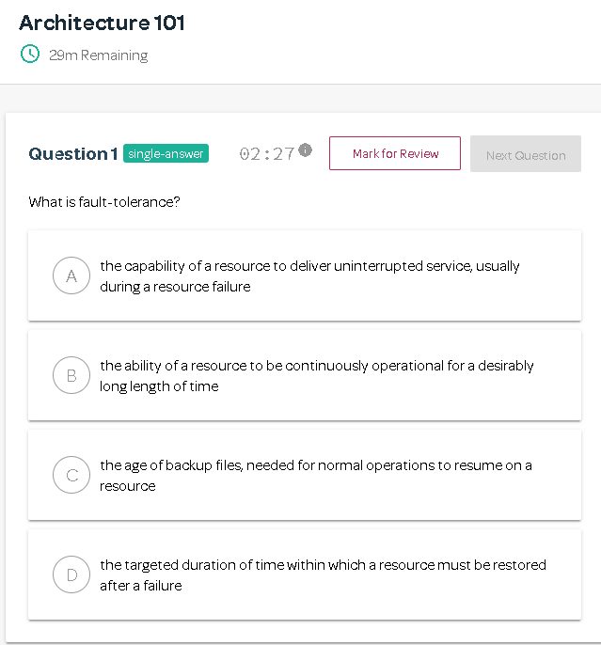

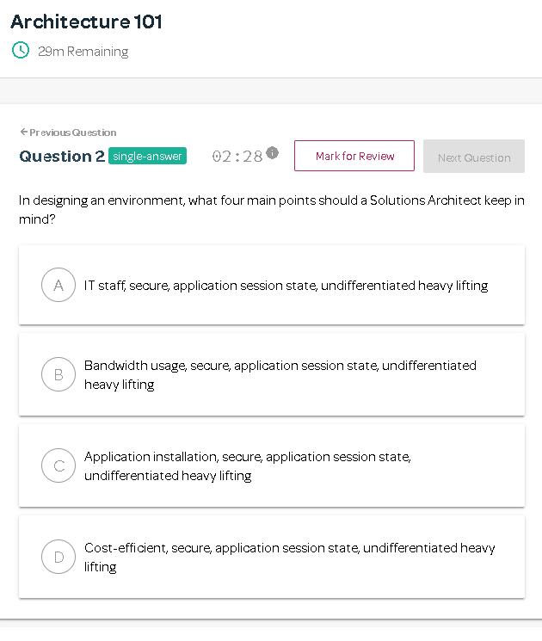

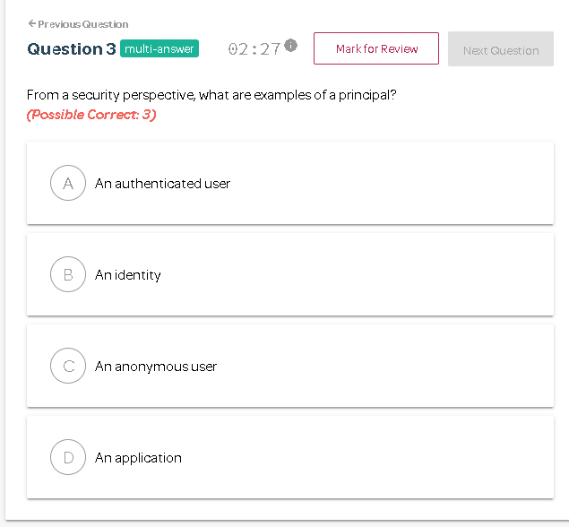

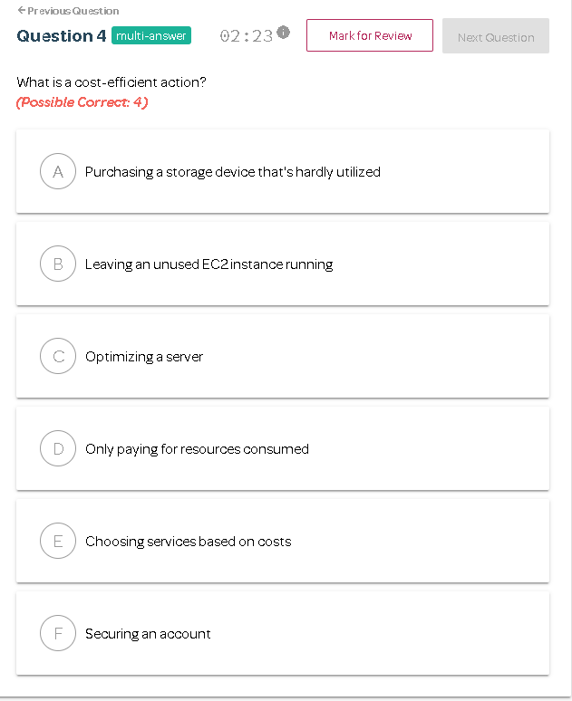

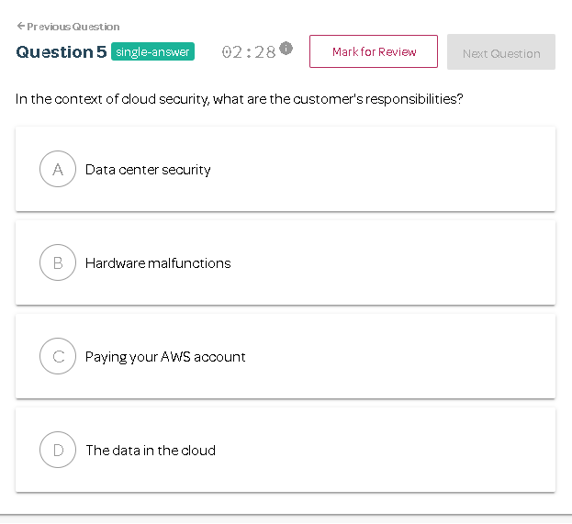

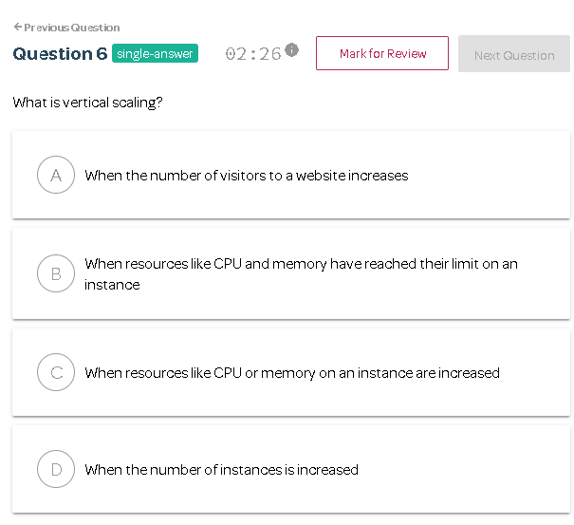

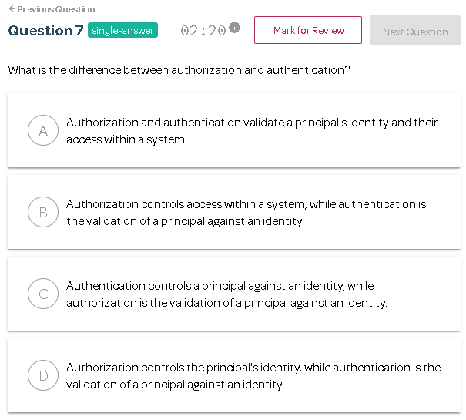

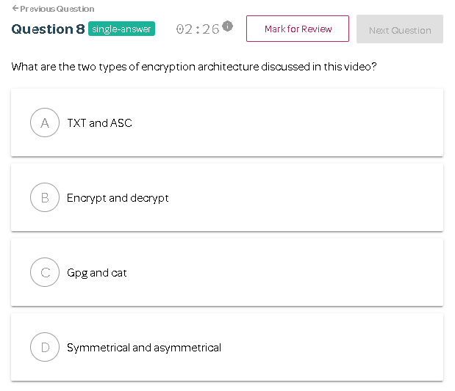

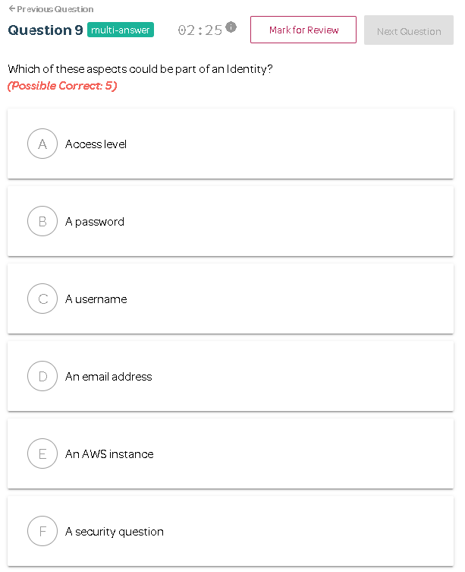

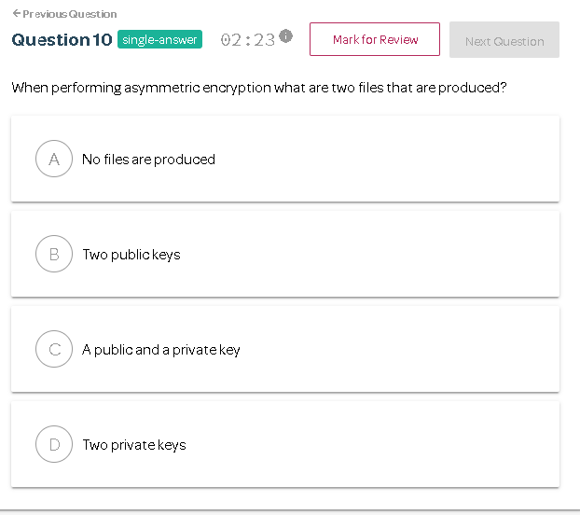

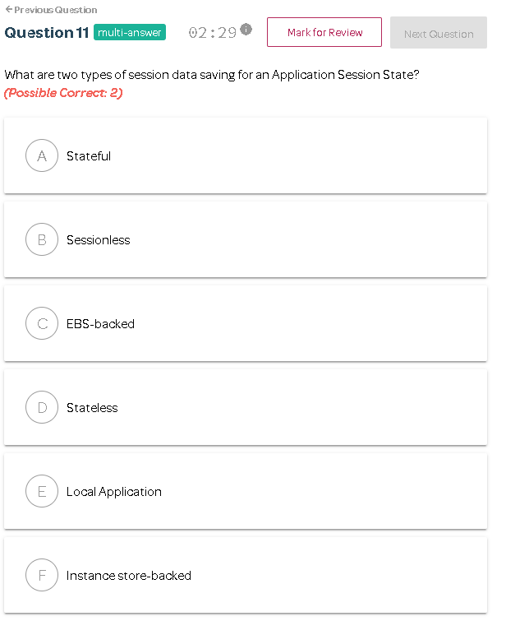

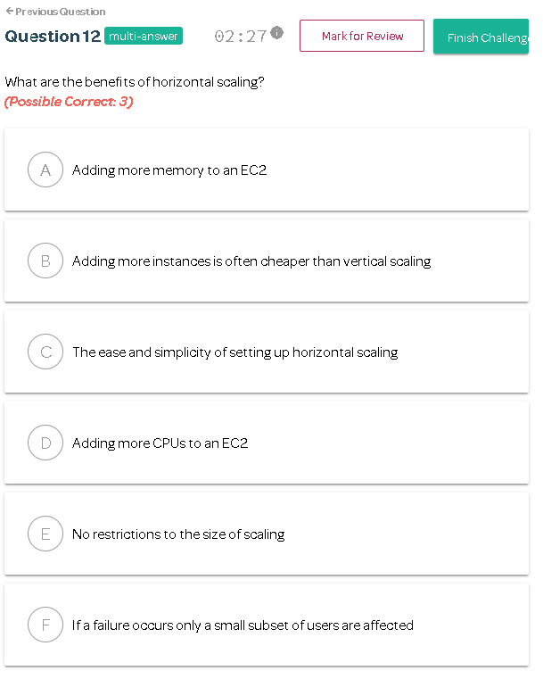

Correct Answers:

 [(https://linuxacademy.com/cp)](https://linuxacademy.com/cp) Community Edition 35 0 ⬄ Support  brett.lohmeier@gmail.com 



Navigation

[Catch up on all the new content and platform updates from the past month in under 3 minutes right here!](https://www.youtube.com/watch?v=6I4RwI5DD1Q)

[(https://www.youtube.com/watch?v=6I4RwI5DD1Q)](https://www.youtube.com/watch?v=6I4RwI5DD1Q)

**Architecture 101**

**

30

minutes

*_rate*

12

Questions

**

2.5 Minutes per

Question

Intermediat

[e](https://app.linuxacademy.com/search?type=Practice%20Exam%20Challenge&difficulty=Intermediate&categories=AWS)

[(](https://app.linuxacademy.com/search?type=Practice%20Exam%20Challenge&difficulty=Intermediate&categories=AWS)

/search?ty

pe=Practice Exa

[m](https://app.linuxacademy.com/search?type=Practice%20Exam%20Challenge&difficulty=Intermediate&categories=AWS)

Challen

[g](https://app.linuxacademy.com/search?type=Practice%20Exam%20Challenge&difficulty=Intermediate&categories=AWS)

e&difficult

[y](https://app.linuxacademy.com/search?type=Practice%20Exam%20Challenge&difficulty=Intermediate&categories=AWS)

=Intermediate&cate

[g](https://app.linuxacademy.com/search?type=Practice%20Exam%20Challenge&difficulty=Intermediate&categories=AWS)

[)](https://app.linuxacademy.com/search?type=Practice%20Exam%20Challenge&difficulty=Intermediate&categories=AWS)

ories=AWS

**Go Back**

**

**Unlock Challenge**

**10**

**

Go Back

**Great Start!**

You did not pass this challenge on this attempt.

**Expectations Report Card**



%

75

**Question List**

Show All Answers

**

1

2

3

4

5

6

7

8

9

10

11

12

**

Architecture 101 75%

# **Exam Breakdown**

Architecture 101

INCORRECT

**1.** What are the benefits of horizontal scaling?

# 

A

Adding more memory to an EC2

**B**

Adding more instances is often cheaper than vertical scaling

**C**

The ease and simplicity of setting up horizontal scaling

**Your Answer: C**

D

Adding more CPUs to an EC2

**E**

No restrictions to the size of scaling

**F**

If a failure occurs only a small subset of users are affected

**Why is this incorrect?**

Horizontal scaling is more challenging to set up than vertical scaling.

Video for reference: Scaling

## Correct Answer: B

**Why is this correct?**

Vertical scaling can be costly while horizontal scaling is cheaper.

Video for reference: Scaling

## Correct Answer: E

**Why is this correct?**

Horizontal scaling suffers from none of the size limitations of vertical scaling.

Video for reference: Scaling

## Correct Answer: F

**Why is this correct?**

Having horizontal scaling means you can easily route traffic to another instance of a server. Video for reference: Scaling

**2.** What are two types of session data saving for an Application Session State?

# 

**Correct Answer: A**

**A**

Stateful

B

Sessionless

C

EBS-backed

**D**

Stateless

E

Local Application

F

Instance store-backed

**Why is this correct?**

Stateful is a method of saving data from an Application Session State locally on the same instance, but data can not be accessed from the session using a different instance. Video for reference: Architecture Odds and Ends

## Correct Answer: D

**Why is this correct?**

Stateless is a method of saving data from an Application Session State remotely on a different instance to maintain uninterrupted user experience.

Video for reference: Architecture Odds and Ends

# 

|  |  |  |
| --- | --- | --- |
| **3.** When performing asymmetric encryption what are two files that are produced? | ** | ** |

**Correct Answer: C**

A

No files are produced

B

Two public keys

**C**

A public and a private key

D

Two private keys

**Why is this correct?**

A public and private key are produced when using asymmetrical encryption. Video for reference: Encryption

INCORRECT

**4.** Which of these aspects could be part of an Identity? **

**Your Answer: E**

**A**

Access level

**B**

A password

**C**

A username

**D**

An email address

**E**

An AWS instance

**F**

A security question

**Why is this incorrect?**

An AWS instance houses an identity, but it is not an identity. Video for reference: Access Management

## Correct Answer: A

**Why is this correct?**

The access level can be part of the principal's identity.

Video for reference: Access Management

## Correct Answer: B

**Why is this correct?**

A password can be part of the principal's identity. Video for reference: Access Management

## Correct Answer: C

**Why is this correct?**

A username can be part of the principal's identity. Video for reference: Access Management

**Correct Answer: D Why is this correct?**

An email address can be a part of the principal's identity.

Video for reference: Access Management **Correct Answer: F**

**Why is this correct?**

A security question can be a part of the principal's identity.

Video for reference: Access Management

**5.** What are the two types of encryption architecture discussed in this video?

# 

**Correct Answer: D**

A

TXT and ASC

B

Encrypt and decrypt

C

Gpg and cat

**D**

Symmetrical and asymmetrical

**Why is this correct?**

Symmetrical and Asymmetrical are the two types of encryption discussed in this video. Video for reference: Encryption

**6.** What is the difference between authorization and authentication?

# 

**Correct Answer: B**

A

Authorization and authentication validate a principal's identity and their access within a system.

**B**

Authorization controls access within a system, while authentication is the validation of a principal against an identity.

C

Authentication controls a principal against an identity, while authorization is the validation of a principal against an identity.

D

Authorization controls the principal's identity, while authentication is the validation of a principal against an identity.

**Why is this correct?**

The key point is that authorization controls where one can go within a system and authentication controls who can get into a system.

Video for reference: Access Management

**7.** What is vertical scaling?

# 

A

When the number of visitors to a website increases

B

When resources like CPU and memory have reached their limit on an instance

**C**

When resources like CPU or memory on an instance are increased

D

When the number of instances is increased

## Correct Answer: C

**Why is this correct?**

Increasing these limits is known as vertical scaling.

Video for reference: Scaling

**8.** In the context of cloud security, what are the customer's responsibilities?

# 

**Correct Answer: D**

A

Data center security

B

Hardware malfunctions

C

Paying your AWS account

**D**

The data in the cloud

**Why is this correct?**

The data in your cloud is the customer's responsibility because AWS takes care of the infrastructure and software. Video for reference: Shared Responsibilities/Security Model

**9.** What is a cost-efficient action?

# 

**Correct Answer: C**

A

Purchasing a storage device that's hardly utilized

B

Leaving an unused EC2 instance running

**C**

Optimizing a server

**D**

Only paying for resources consumed

**E**

Choosing services based on costs

**F**

Securing an account

**Why is this correct?**

Optimizing a server can reduce hosting costs and fits with the definition of cost-efficiency.

Video for reference: Architecture Odds and Ends

## Correct Answer: D

**Why is this correct?**

Paying for under-utilized services does not align with the definition of cost-efficiency.

Video for reference: Architecture Odds and Ends

## Correct Answer: E

**Why is this correct?**

Choosing services based on cost aligns with the definition of cost-efficiency.

Video for reference: Architecture Odds and Ends

## Correct Answer: F

**Why is this correct?**

Leaving an account insecure can be a costly mistake. Tightening security to an account is a cost-efficient action.

Video for reference: Architecture Odds and Ends

INCORRECT

**10.** From a security perspective, what are examples of a principal?

# 

**Your Answer: B**

**A**

An authenticated user

**B**

An identity

**C**

An anonymous user

**D**

An application

**Why is this incorrect?**

An identity has established the data of a principal. A principal is could be anonymous or they could authenticate to become an identity.

Video for reference: Access Management

## Correct Answer: A

**Why is this correct?**

An authenticated user falls under the definition of a principal. Essentially a principal is a person, application or a system that can make an authenticated or anonymous request to perform an action on a system.

Video for reference: Access Management

## Correct Answer: C

**Why is this correct?**

An anonymous user falls under the definition of a principal. Essentially a principal is a person, application or a system that can make an authenticated or anonymous request to perform an action on a system.

Video for reference: Access Management

## Correct Answer: D

**Why is this correct?**

Essentially a principal is a person, **application** or a system that can make an authenticated or anonymous request to perform an action on a system.

Video for reference: Access Management

**11.** In designing an environment, what four main points should a Solutions Architect keep in mind?

# 

**Correct Answer: D**

A

IT staff, secure, application session state, undifferentiated heavy lifting

B

Bandwidth usage, secure, application session state, undifferentiated heavy lifting

C

Application installation, secure, application session state, undifferentiated heavy lifting

**D**

Cost-efficient, secure, application session state, undifferentiated heavy lifting

**Why is this correct?**

These four main points should be the framework when designing an environment.

Video for reference: Architecture Odds and Ends

**12.** What is fault-tolerance?

# 

**Correct Answer: A**

**A**

the capability of a resource to deliver uninterrupted service, usually during a resource failure

B

the ability of a resource to be continuously operational for a desirably long length of time

C

the age of backup files, needed for normal operations to resume on a resource

D

the targeted duration of time within which a resource must be restored after a failure

**Why is this correct?**

Fault-tolerance is a resource's ability to deliver uninterrupted service, usually during a system failure.

Video for reference: High-Availability vs. Fault-Tolerance